Using Subtitle Workshop (for Encore DVD—Free download)
First, have your movie converted to AVI so it will be ready to import to Encore later. Use this file as you generate the subtitles. Subtitle files are honestly nothing more than Notepad files (text files) that have start and end times for captions and the text. That’s it. This free program will let you press buttons to set that rather than manually writing down the timecode. Yay!
- Save your video/export in Premiere (or whatever program you’re editing in) to AVI (File>Export> Movie in Premiere).
- Launch Subtitle Workshop (if no icon, look under Programs, URU Soft).
- Click Movie>Open and select your video file.
- Click File> New Subtitle to get started! The first subtitle line will magically appear:
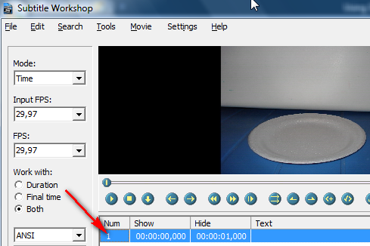
- Click the Play button. Right before words are spoken, pause. Then, click the Set start time button:
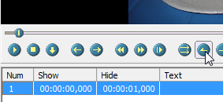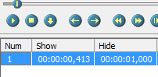 (updates)
- Click the Play button. Right after the words stop, pause. Then, click the Set final time button:
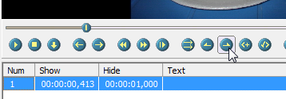 Then, click in the “Hide” number box to update the timecode. 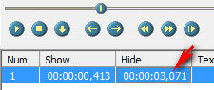
- Then, while still clicked on subtitle number 1, type in the text you want to appear in the box at the bottom:
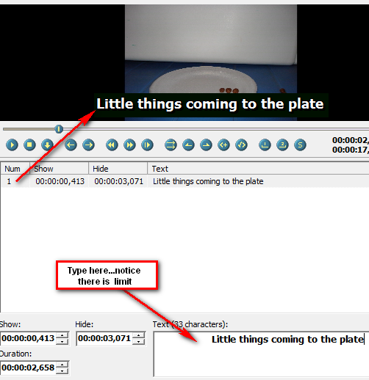
- To do the next one, press the Insert button on the computer keyboard. It will automatically start right after the other one finishes. But, if you want to set a specific start time, repeat the process used for the first one. Then, set the end time. Easy! Repeat until the video is complete.
- Press Play and watch it back to make sure it matches.
- To save…click File> Save As
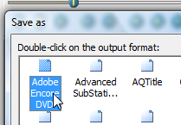And double click on Adobe Encore DVD.
- It will generate a text file. Just save it with your project so you know where it is when it’s time to create the DVD!
Encore DVD Instructions—Subtitles
Once you have created the text file in Subtitle Workshop, the rest is pretty easy. Launch Encore and author your DVD like normal.
If everything is done and you wish to add subtitles, simply open the Timeline of the video you wish to add the subtitles to by double clicking it in the Project window:
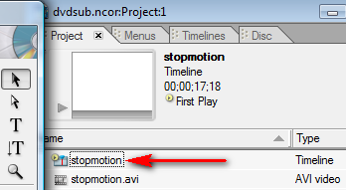
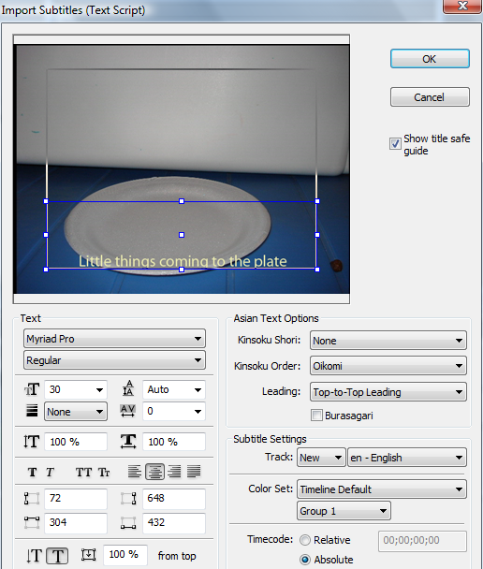
Now, click on the Timeline at the bottom, and then select the menu at the top called Timeline and choose:
Browse and find your text file that has all the subtitle information.
Once you do that, a window will appear that will allow you to customize the subtitle. I would not do much here, but you can alter the size of the titles or the alignment (it will be left automatically, so you might want to change it to center, but it’s personal preference). This will automatically be set to English as well, so if you were subtitling in a different language, change that as well:

That’s it. You should see the Subtitles at the bottom of the Encore Timeline and if you scrub, they should be in time with the video:
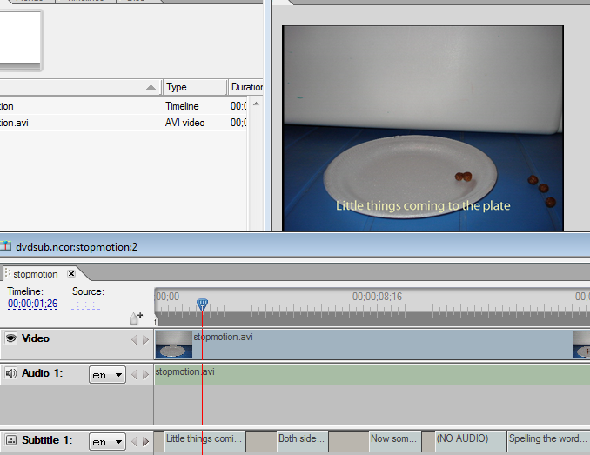
Save and continue on as always!
Just note that when you preview the DVD, you have to turn on the subtitles to be able to see them.
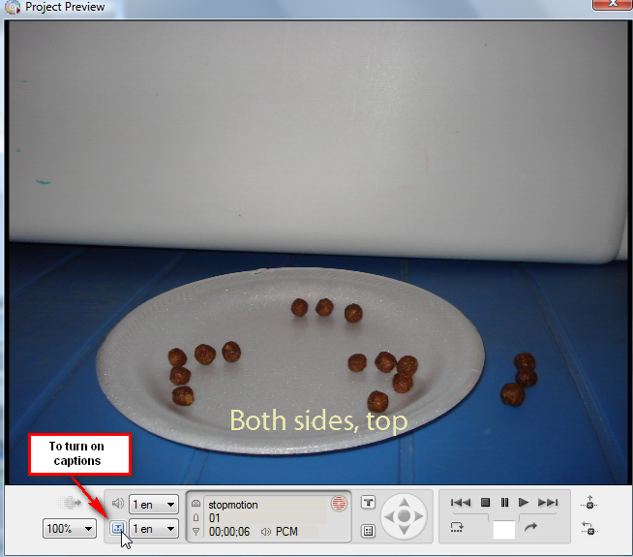
And, when you burn the DVD and watch it in a DVD player or on a computer in Windows Media Player, you have to turn on captions or subtitles for it to work. Most of those are not set to use captions/subtitles by default.

